function [] = myUnsharpMasking()
myNumOfColors = 200;
myColorScale = [ [0:1/(myNumOfColors-1):1]' , [0:1/(myNumOfColors-1):1]' , [0:1/(myNumOfColors-1):1]' ];
imageList = ["../data/lionCrop.mat" "../data/superMoonCrop.mat"];
scalingParam = [3, 7];
sigmaParam = [1.25 4];
filterSize = [7 9];
imgMat = load(imageList(1)).imageOrig;
img = mat2gray(imgMat);
origStretchedImg = myLinearContrastStretching(img);
newImg = sharpen(img, scalingParam(1), sigmaParam(1), filterSize(1));
newStretchedImg = myLinearContrastStretching(newImg);
figure(), imagesc(origStretchedImg), title("Original Image"), colormap(myColorScale), daspect([1 1 1]), colorbar, truesize;
figure(), imagesc(newStretchedImg), title("Sharpened Image"), colormap(myColorScale), daspect([1 1 1]), colorbar, truesize;
imgMat = load(imageList(2)).imageOrig;
img = mat2gray(imgMat);
origStretchedImg = myLinearContrastStretching(img);
newImg = sharpen(img, scalingParam(2), sigmaParam(2), filterSize(2));
newStretchedImg = myLinearContrastStretching(newImg);
figure(), imagesc(origStretchedImg), title("Original Image"), colormap(myColorScale), daspect([1 1 1]), colorbar, truesize;
figure(), imagesc(newStretchedImg), title("Sharpened Image"), colormap(myColorScale), daspect([1 1 1]), colorbar, truesize;
end
function [sharpenedImg] = sharpen(img, scale, sigma, fltSize)
filter = fspecial('gaussian', fltSize, sigma);
blurImg = imfilter(img, filter, 'conv');
unsharpMask = img - blurImg;
sharpenedImg = img + (scale*unsharpMask);
end
function [stretchedImg] = myLinearContrastStretching(img)
Imean = mean2(img);
Istd = std2(img);
Imin = Imean - 3*Istd;
Imax = Imean + 3*Istd;
stretchedImg = (img - Imin)/(Imax-Imin);
[M, N] = size(img);
for i = 1:M
for j = 1:N
if img(i,j) < Imin
stretchedImg(i,j) = 0;
elseif img(i,j) > Imax
stretchedImg(i,j) = 1;
end
end
end
end
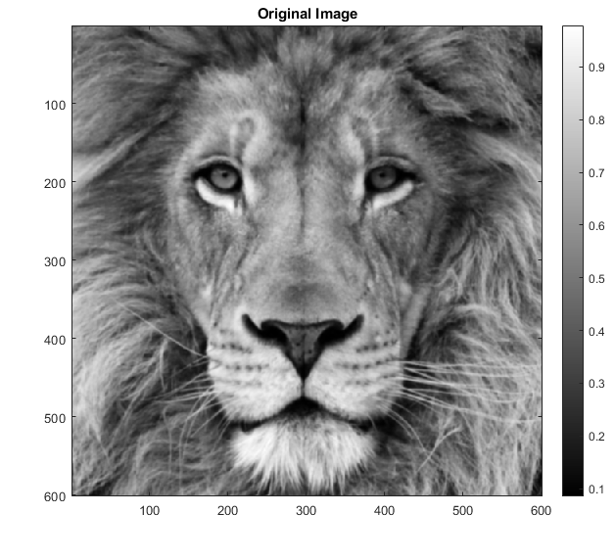
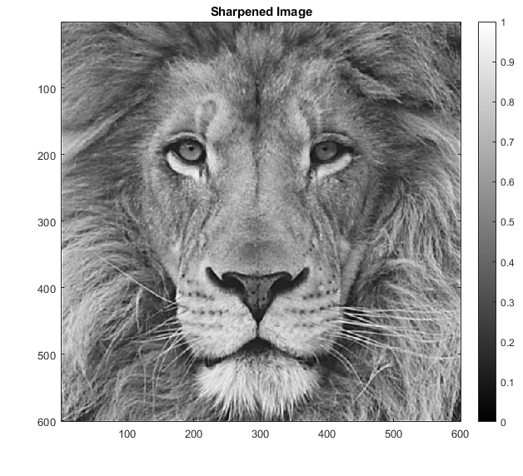
Tuned Parameters for the Lion Image:
- Sigma value used for the Gaussian filter used for blurring the input image is 1.25.
- Filter size used for convolving with the input image is 7.
- Scaling Factor used to scale the unsharp mask while adding to input image is 3.
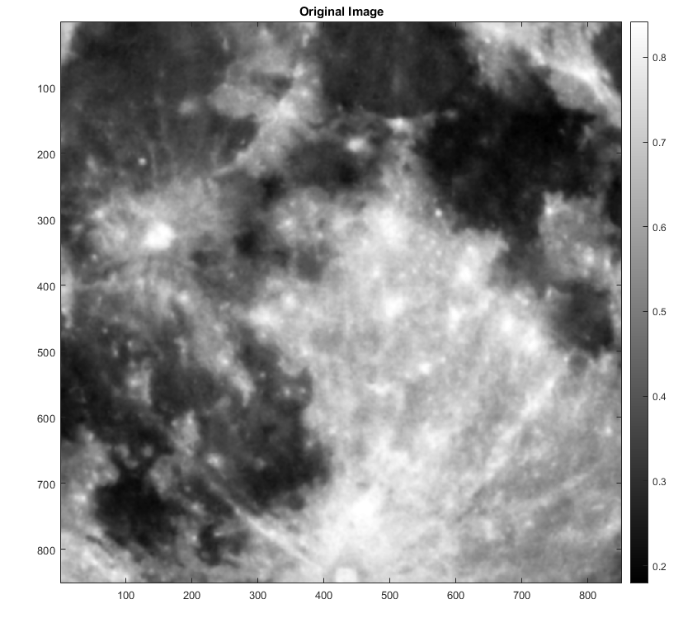
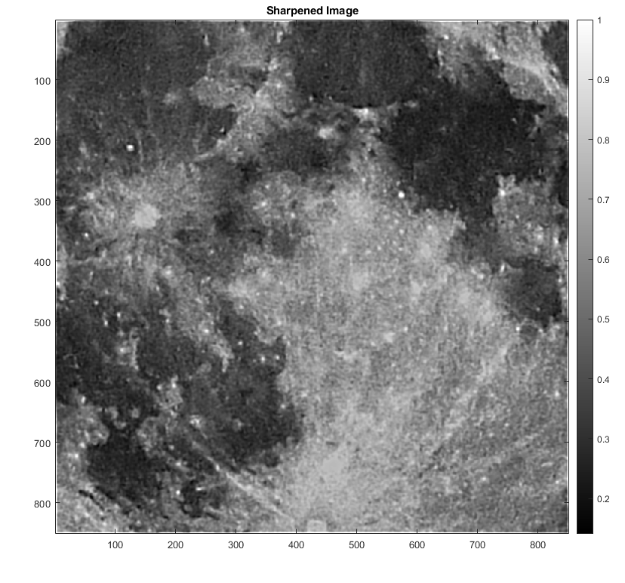
Tuned Parameters for the Moon Image:
- Sigma value of the Gaussian filter used for blurring the input image is 4.
- Filter size used for convolving with the input image is 9.
- Scaling Factor used to scale the unsharp mask while adding to input image is 7.
Image Sharpening:
Image Sharpening through Unsharp Masking was done as follows:
- A Gaussian Filter of size F x F, with a tuned value for the sigma, was convolved with the input image to obtain the blurred image.
- The negative of the output of above operation was added to the input image to obtain the unsharp mask.
- This unsharp mask was scaled with a tuned scaling parameter and added to the input image.
This approach attempts to create a Mexican Hat filter (which can be approximated as the Difference of Gaussians (DoG)) and use it to sharpen the image by introducing a “dip” and “peak” in the intensity near any edge in the image.

Linear Contrast Stretching:
If the minimum intensity in the image was mapped to 0 and the maximum intensity was mapped to 1, and the in-between intensities were correspondingly mapped linearly, then the obtained image was observed to be highly “greyish”.
To avoid this, a different piecewise-linear operation was performed wherein, the mean and the standard deviation of the image was calculated and the intensities below (mean – 3*std) were mapped to 0, the intensities above (mean + 3*std) were mapped to 1, and then the remaining intensities were correspondingly mapped linearly.
This gave a much better result compared to the completly linear contrast stretching.

Published with MATLAB® R2020a

